UNIT 1
LESSON 4 – MY FAVOURITE BAND
THE COOLS
- 1
Look at the photo.
Pogledaj fotografiju.
a) Find out the names of the three boys.
Pronađi imena trojice mladića na fotografiji.

JACK
ZACK
JEREMY

b) Copy their names on the lines.
Prepiši njihova imena na crte.

________________ _________________ ________________

2 Complete the sentences with: IS, ARE or HAS GOT.
Nadopuni rečenice riječima:.

IS | ARE | HAS GOT
JE | SU | IMA

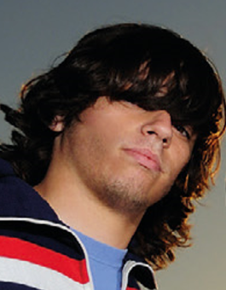
1 Jeremy _____IS_____ a boy.
Jeremy je mladić.
He ________________ brown hair.
On ima smeđu kosu.
He ________________ brown eyes.
On ima smeđe oči.

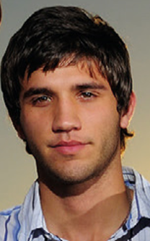
2 Zack ___________ a boy.
Zack je mladić.
. He ________________ short hair.
On ima kratku kosu.
He _______________ brown hair.
On ima smeđu kosu.

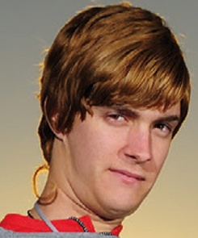
3 Jack _____________ a boy.
Joseph je mladić.
He _______________ red hair.
On ima crvenu kosu.
He ______________ brown eyes.
On ima smeđe oči.

4
They _________________ The Cools band.
Oni su bend The Cools.

They __________________ Penelope's favourite band.
Oni su Penelopin omiljeni bend.

- 2
Read the sentences. Circle YES or NO.
Pročitaj rečenice. Zaokruži YES za točnu ili NO za netočnu rečenicu.

Zack is a girl. YES NO
Zack je djevojka.
Zack has got long hair. YES NO
Zack ima dugu kosu.
Zack has got brown hair. YES NO
Zack ima smeđu kosu.
Zack has got brown eyes. YES NO
Zack ima smeđe oči.

Jeremy is a boy. YES NO
Jeremy je mladić.
Jeremy has got short black hair. YES NO
Jeremy ima kratku crnu kosu.
Jeremy has got green eyes. YES NO
Jeremy ima zelene oči.

Jack is a girl. YES NO
Jack je djevojka.
Jack has got long blond hair. YES NO
Jack ima dugu plavu kosu.
Jack got black eyes. YES NO
Jack ima crne oči.

- 3
- Circle the correct word to make a sentence.
Zaokruži točnu riječ.

- Zack is A a boy. (mladić)
Zack je B a girl. (djevojka)

- Zack has got A black hair. (crnu kosu)
Zack ima B brown hair. (smeđu kosu) ZACK

- Jack is A a man. (muškarac)
Jack je B a boy. (mladić)

- Jack has got A blue eyes. (plave oči)
Jack ima B brown eyes. (smeđe oči) JACK

- Jeremy is A a boy. (dječak)
Jeremy je B a woman. (žena)

- Jeremy has got A blond hair. (plavu kosu)
Jeremy ima B brown hair. (smeđu kosu) JEREMY

- Jeremy has got A long hair. (dugu kosu)
Jeremy ima B short hair. (kratku kosu)

- 4 Complete the sentences with the words from the box.
Dovrši rečenice uz pomoć riječi iz okvira.

AM | SAM
IS | JE
ARE | SU
ISN'T | NIJE
- Zack IS a boy.
Zack je mladić.
- Joseph__________ a girl.
Joseph nije djevojka.
- Jack __________ a boy.
Jack je mladić.
- Jack __________ a woman.
Jack nije žena.

5 I _________ Zack.
Ja sam Zack.

6 We _________________ The Cools.
Mi smo bend The Cools.

- 5 Jeremy is talking about himself and his friend Jack.
Jeremy priča o sebi i svom prijatelju Jack-u.
a) Read the sentences.
Pročitaj rečenice.

1 I have got brown hair.
Ja imam smeđu kosu.

2 Jack has got red hair.
Jack ima riđu kosu.
Jack ima

3 I have got long hair.
JEREMY Ja imam dugu kosu.
.

4 Jack has got short hair.
Jack ima kratku kosu.

b) Complete the sentences with HAVE GOT or HAS GOT.
Dovrši rečenice s HAVE GOT ili HAS GOT.

JEREMY ZACK JACK

- Jeremy HAS GOT long brown hair.
Jeremy ima dugu smeđu kosu.
- Zack _______________ short brown hair.
Zack ima kratku smeđu kosu.
- Jack_______________ brown eyes.
Jack ima smeđe oči.
- Jack _______________ red hair.
Jack ima riđu kosu.

- I_________________ kratku kosu.
Ja imam kratku kosu.

- 6 Write about your favourite singer.
Piši o svom omiljenom pjevaču ili pjevačici.
a) Glue a picture or draw your favourite singer in the frame.
Nalijepi sliku ili nacrtaj svog omiljenog pjevača / pjevačicu u okvir.

b) Complete the sentences.
Dovrši rečenice.

1 My favourite singer is _______________________.
Moj najdraži pjevač/ pjevačica je

2 He/she is _________________________ years old.
On /ona ima godina.

3 He/she has got_________________________eyes.
On /ona ima oči.

4 He/she has got _________________________ hair.
On /ona ima kosu.

5 He/ she is ___________________________ .
On/ ona je

